CHURCH CALENDAR

April 30 Baby Shower for Catherine Eckert @ 10 am @ Fellowship Fall
SECC Pathfinder Pinewood Derby 9-3 o’clock

May 2 Adventurer/Pathfinder meetings, 6:30 pm
May 6 Ten Commandments Day
Adventurer Investiture, 4:00 pm, Fellowship Hall

May 7 Adventurer Outing, Kite Day
May 9 Adventurer meeting, 6:30 pm (year end party)
May 12-14 Pine Springs Church Retreat (Mother’s Day) No potluck today

May 16 Pathfinder meeting, 6:30 pm
May 20 Communion Service – No potluck today

May 21 Pathfinder Fair
May 23 Finance & Board meetings
May 27 Sharing & Caring

June 4 Adventurer Year End Outing – San Diego Zoo

PRAYER REQUEST AND PRAISES

Reza Nazeri: That God work out His providence so Reza can be reunited with wife Nahid and children Ayan and Shayan soon.
Health: Cathy & Paul Egly’s friend Marie Francoise Bach undergoing testing; Dr. Brown; Shari Ide; Shashi Lopez’s neighbor Heather Herrera; Selina Preciado’s daughter Reina Abeytia & sister-in-law Maria Tapia; Warren Waggerby, Julie Heslink; Charlotte Washington’s sister Vanessa; Sylvia Perez’s niece Ellie; Kari Roosenberg’s cousin Jennifer; Bud Steen; Aaron Moreno; Ted & Brownie Anderson; Wes Coble; Nancy Coble; Bob & Bev Link’s nephew Kelly; Don & Dolores Messina; Karen Houghton’s father, Chuck Szmanda.
Other Needs: Jon Messina, Oliver Jacques; Cynthia Aspiotes; Richard & Krista VanDyke; friend of Carol Frazer’s daughter Sherry, Kimberly Torres for foreign missionary work in Cambodia & deployment to Iraq of Barbie Blysma’s son Brock and Coel Tyrell.
Peace & Light for Dark Times: Families and loved ones of those serving in Iraq and of the casualties, which are now nearly 2300 and 17,000 wounded/ The passing of Helen Dumbeck who went to her rest on Saturday night, April 22.
Praises: from Reina Abeyta (Selina’s daughter) a huge THANK YOU for all the cards, call and especially your fruitful prayers as she continues to heal from her eye injury.

The flowers in the Sanctuary today are in memory of Helen Dumbeck’s passing

Helen Dumbeck, Fallbrook’s oldest member, went to her rest April 22. She was over 99 years old. Her family is so appreciative of the Pathfinder & Adventurer clubs for their visits and songs. And to all those who called, sent cards, visited and brought flowers during her last few years.

Services will be private. In lieu of flowers, donations should be made to the Fallbrook SDA Church designated for the Pathfinder and Adventurer clubs.

UPCOMING EVENTS – NOTICES

Please return books & tapes for Easter Cantata to church office or piano with your name.

Young People Ages 10-13 …. Want to learn more about our beliefs and prepare yourself for baptism? Please contact Bryan Cooke or the office for more information.

Breathe Free Stop Smoking Program – October, 2006. Help is needed for: advertising, registration, testimonies by ex-smokers, meal planning and graduation. Medical professionals are needed to speak on benefits of a tobacco-free lifestyle.

VACATION BIBLE SCHOOL – June 19-23 (evening) Registration begins today for two weeks. Volunteers needed to help prepare crafts, cut out materials and felts, prepare and hand out snacks, assist teachers, students. Volunteer sign ups can be done on registration form, by calling or emailing the church Your donations of funds for snacks, etc. are greatly appreciated. Please mark your tithe envelope for VBS.

HOMELESS Ministry. We need your help!!! Please bring socks, men & women’s underwear, clothes, sweatshirts, jeans, jackets, blankets, hats & shoes. The ministry will now serve the poor and needy 6 times annually: May 20, July 17, September 15 & November 18. Please mark your calendar and plan to participate. Drivers (adults) needed to provide transportation for our young people who want to attend. We don’t want to have to turn down our youth because there is not enough adult supervision and transportation. Please PRAYERFULLY consider participating in this ministry with your children. Contact Pastor Mataafa for more information.

Attention: EAA & EJA Alumni: Plans are underway for this year’s Alumni Homecoming on May 6-7, 2006, and we would like to include you in the festivities: May 6: 10:45 am Church Service; 7:30 pm Alumni Meeting & Gym Night; and May 7: 9:30 am Softball, Football & Family Picnic. If you have not received a “Save the Date” card, we don’t have your current address in our database. You can also help by sending addresses of classmates to alumni@eaaschool.org or calling 760.746.1800 with info on fellow graduates. Thanks!

Building Fund Account
Goal $385,000.00 Actual $284,693.10

Combined Budget for April, 2006

Budget $12,560.00 Actual $10,843.72

Community Service meets this Monday, May 1, 2006,

10-12 @ Fellowship Hall…. Learn how to knit or crochet, enjoy a good time with other church women. Children welcome. All supplies will be provided, but if you have needless or yarn…please bring.

Fallbrook Seventh-day Adventist Church
1200 Rainbow Valley Boulevard
Fallbrook, CA 92028

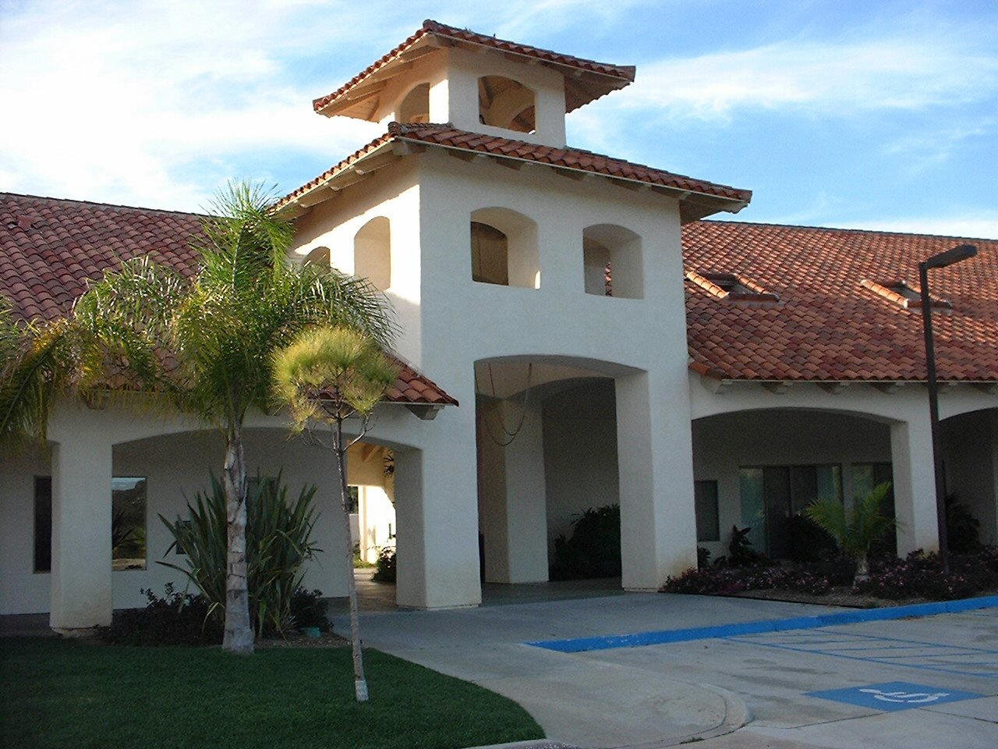

Sabbath, April 29, 2006

In respect to God and as a courtesy to the speaker and others
in the congregation Please turn off your cell phones
in the Sanctuary. Thank you!

