CHURCH CALENDAR

Feb 25 Sharing & Caring (optional)

Feb 28 Finance/Board Meetings CANCELLED

March 1 Seven Mysteries Solved (8th & final week)
March 3 Vespers @ Washington home

March 5 Baby Shower - Heidy William (dtr of -Manny & Dorthy Grey)
March 7 Adventurer/Pathfinder meeting, 6:30 pm
Finance/Board Meetings 6:00 & 7:00 pm (note change)
March 10 Vespers @ Mataafa home
March 11 Caring & Sharing w/Pathfinders

March 12 Adventurer Outing – Kite Day
March 14 Adventurer Staff Meeting
March 17 Vespers @ Tobing home
March 18 Social – Game Night

March 19 Pathfinder Garage Sale
March 21 Adventurer/Pathfinder meetings, 6:30 pm
March 24 Vespers @ Uraine home
March 25 Sharing & Caring
March 28 Finance & Board Meetings

April 1 Teen River Trip
April 4 Adventurer/Pathfinder Meetings, 6:30 pm
April 8 Sharing/Caring with Adventurer’s

April 9 Easter Cantata Rehearsal
April 11 Adventurer Staff Meeting
April 14 Easter Cantata evening performance
April 15 Easter Cantata performance Sabbath afternoon

April 16 Easter Sunday - Adventurer Fun Day
April 22 Sharing & Caring

April 23 Social – International Dinner
April 25 Finance & Board meetings

Information coming for REVELATION SPEAKS PEACE: UNLOCKING THE SIGNS featuring Shawn Boonstra, It Is Written Speaker/Director. Starts here March 10, 7 – 8:30 every night except Monday & Thursday, through April 8.

Please complete a Membership Information Survey
Located in the church lobby. All information is CONFIDENTIAL!!

The flowers in the Sanctuary today
Celebrate the birthdays of
Pastor Ulisese & Nathaniel Mataafa
Happy Birthday

Pick up your 2005 Receipt of Contributions
In the CHURCH LOBBY

PRAYER REQUEST AND PRAISES

Reza Nazeri: That God work out what is right with the Canadian Immigration meeting; and that he will be reunited with wife Nahid and children Ayan and Shayan soon.
Health: Dr. Brown; Shari Marsala; Shashi Lopez’s neighbor Heather Herrera; Dean Mallory, being treated for throat cancer; Selina Preciado’s daughter Reina Abeytia; Warren Waggerby, Julie Heslink; Bruce Hildebrand; Charlotte Washington’s sister Vanessa; niece of Sylvia Perez, 2 yr old Ellie; Kari Roosenberg’s cousin 21 yr old Jennifer; Shirley Devine’s daughter recovering from spinal surgery and on the mend. Selina Preciado’s sister in law, Maria Tapia for surgery, Bud Steen, Emma Marie Brownlow, Alyssa Storey, Jewell Mitchell, Aaron Moreno injuries from snowboarding accident, The Anderson’s, Ted & Brownie & Wes Coble
Other Needs: Richard VanDyke & family; Oliver Jacques; Cynthia Aspiotes; Carol Frazer’s friend’s daughter Sherry; Father of Jeannette Zimmerman, David Luma, needs prayer for healing; Kimberly Torres for foreign missionary work in Cambodia.
Peace & Light for Dark Times: Families and loved ones of those serving in Iraq and of the casualties, which are now over 2300. The Wright family and the loss of Gloria Wright.

UPCOMING EVENTS – NOTICES

Mark your calendar for March 11 @ Loma Linda SDA Church …

HIS VOICE will be performing for vespers that afternoon.

A “book of memories” for Gloria Wright’s family is available in the church lobby today or you may send cards of condolence to the family of Gloria care of:

Ted and Martha Wright

1920 Lawrence Avenue

Lockport, IL 60441

Building Fund Account
Goal $385,000.00 Actual $280,317.59

Combined Budget for February, 2006

Budget $12,560.00 Actual $6,676.66

Next week’s Offering: Church Budget

Celebrating February Birthday’s

Tessa Chaves, Pamela Ciano, Summer Egly, Mark Fiske

Holly Hayton, Sue Knutson, Carrie Kresser, Hermann Kresser, Linda Leal, Tito Lopez, Shashi Lopez, Nathaniel Mataafa, Ulisese Mataafa,

Patrick Robinson & Jane Steen

Celebrating February Anniversaries

Mary Lou & Jim Bear

James & Jody Mueller

Sonja & Darrell Nicola

Danilo & Lois Soler

VACATION BIBLE SCHOOL -- Summer 2006.

Tentative date: Evenings, June 19-23.

Co-directors Sonja Hults & Kari Roosenberg.

Most important that teachers are available in order to proceed with plans for Vacation Bible School. Please pray for guidance in making a decision as to your availability for Vacation Bible School. More information will be coming! Contact Brenda Jones or secretary to volunteer for teacher positions.
Fallbrook Seventh-day Adventist Church
1200 Rainbow Valley Boulevard
Fallbrook, CA 92028

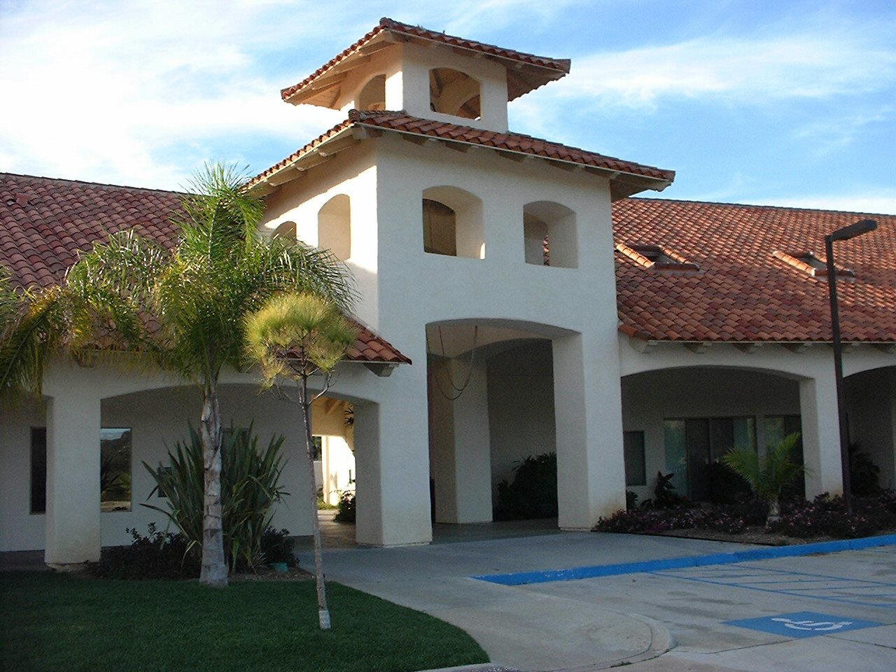

Sabbath, February 25, 2006

In respect to God and as a courtesy to the speaker and others
in the congregation Please turn off your cell phones
in the Sanctuary. Thank you!

